News Activity 1°Medio
I.- Instructions: Read the following news and translate it into Spanish. (Lea la siguiente noticia y traduzca al español.)
Science & Environment

Fossil 'wonderchicken' could be earliest known fowl
By Helen BriggsBBC News

A newly discovered fossil bird could be the earliest known ancestor of every chicken on the planet.
Living just before the asteroid strike that wiped out giant dinosaurs, the unique fossil, from about 67 million years ago, gives a glimpse into the dawn of modern birds.
Birds are descended from dinosaurs, but precisely when they evolved into birds like the ones alive today has been difficult to answer.
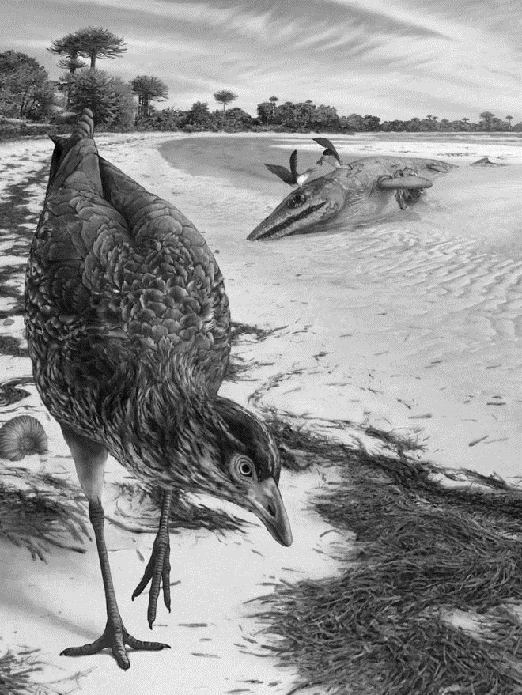
This is due to a lack of fossil data.
The newly discovered - and well-preserved - fossil skull should help fill in some of the gaps.
"This is a unique specimen: we've been calling it the 'wonderchicken'," said Dr Daniel Field of the University of Cambridge.
"It's the only nearly complete skull of a modern bird that we have, so far, from the age of dinosaurs and it's able to tell us quite a lot about the early evolutionary history of birds."
The fossil bird has been named Asteriornis maastrichtensis, after Asteria, a Greek goddess of falling stars who turns into a quail. It was found in a quarry on the Netherlands-Belgium border.
The bird weighed in at just under 400g and was an early member of the group that gave rise to modern-day chickens, ducks and other poultry.
At the time, the region was covered by a shallow sea, and conditions were similar to modern tropical beaches. With its long, slender legs, the bird may have been a shore dweller.
"Birds are such a conspicuous and important group of living animals, being able to say something new about how modern birds actually arose is really a significant thing for palaeontologists and evolutionary biologists," said Dr Field.
"The wonderchicken is going to rank as a truly important fossil for helping clarify the factors that actually gave rise to modern birds.”

