ENGLISH, Contenido: Present Simple, Unidad I: Opinions and Feelings
NOMBRE: ____________________________________________________ CURSO: ______ FECHA: ___________

Objetivo:
- Repasar presente simple para expresar opiniones y sentimientos utilizando la conjunción “when”.

DO NOW: Look at the chart. Take notes about the content (HACER AHORA: Mira el cuadro. Toma nota sobre el contenido).
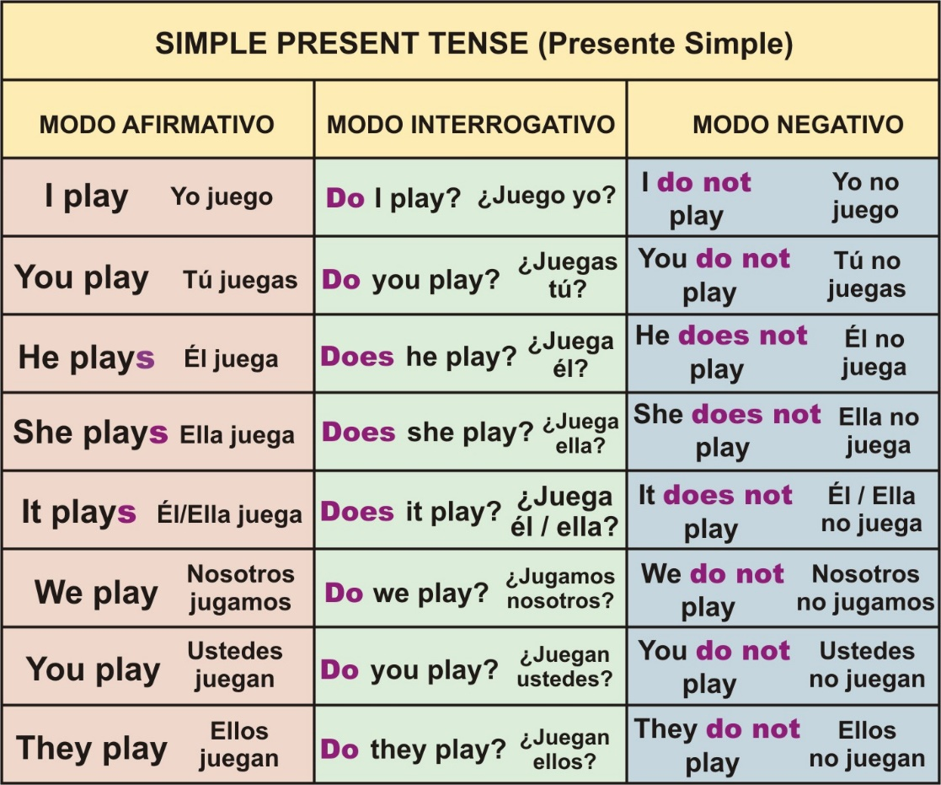

EN AFIRMACIÓN al verbo de “He-She-It” siempre se le agrega una –s, -es- o –ies por ser 3eras. personas.
EN NEGACIÓN el verbo de “He-She-It” no cambia, puesto que el auxiliar “does not” está presente.

EN INTERROGACIÓN se utiliza el auxiliar DO (para plurales) y DOES (para 3eras. personas) para iniciar la pregunta, luego sigue el pronombre y cierra con el verbo (acción).

INTRODUCTION TO THE NEW CONTENT / INTRODUCCIÓN AL CONTENIDO NUEVO

Expressing opinions and feelings.

Categorize the words in the box into three categories: “positive,” “negative,” and “neutral” feelings. Then translate. | Categorice las palabras en la caja en tres categorías: sentimientos “positivos”, “negativos” y “neutrales”. Luego traduzca.
anxious – happy – tired – well rested – bored – sad – busy – worried – mean – annoyed – afraid – lucky

Positive Feelings |  | Neutral feelings |  | Negative feelings
 |  | Busy | Ocupado
GUIDED PRACTICE / PRÁCTICA GUIADA

Ya habiendo recordado algunos sentimientos, en esta guía profundizaremos más sobre la expresión “I feel” (Yo siento). Tomemos atención a la siguiente tabla:

First case: como podemos ver, esta oración simple consta de Sujeto + verbo (acción) + sentimiento.

Subject | Verb | Feeling
I | feel | well rested
Yo | me siento | bien descansado/a.

Second case: a la misma oración le agregamos más information para explicar CUANDO nos sentimos así.

Subject | Verb | Feeling | Conjunction | Subject | Verb | Complement
I | feel | well rested | when | I | sleep | a lot.
Yo | me siento | bien descansado/a | cuando | yo | duermo | mucho.
I feel well rested when I sleep a lot.
I feel well rested when I sleep a lot.
El complemento es un elemento en la oración que podría quitarse y aun así estaría grammatically correct. Entrega extra information.
La conjunción “WHEN” (cuando) tiene la función de unir two ideas (well rested + sleep) en este example.
Los verbos “feel” y “sleep” no cambian puesto que el sujeto no es he/she/it.

PRACTICE CASE: Complete con la información correspondiente in the blank spaces.

Subject | Verb | Feeling | Conjunction | Subject | Verb | Complement
 |  | anxious | when | girls | talk to me
Yo | me siento |  |  |  |  | en las fiestas.
___________________________________________________________________________________.
WAIT! ¿What happens with he/she/it?

Excellent question! La estructura anterior aplica para los pronombres I – You – We – They. So… What happends with he – she – it? Let’s see the example. Luego, tú completa the blank spaces!

Subject | Verb | Feeling | Conjunction | Subject | Verb | Complement
He | feels | busy | when | he | plays videogames | on the computer.
Él | se siente | ocupado | cuando | Él | juega videoguejos | en el computador

Subject | Verb | Feeling | Conjunction | Subject | Verb | Complement
 |  | worried |  | her best friend |  | to classes.
Ella |  |  | cuando | su mejor amiga | no va
Tip: el verbo acá es GO, pero REVISA LA TABLA DEL INICIO para ver la forma negativa con SHE.

INDEPENDENT PRACTICE / PRACTICA INDEPENDIENTE

Complete the sentences with the correct present simple verbs in positive and negative form. | Complete las oraciones con la forma correcta del presente simple de los verbos en forma positiva y negativa.

Positive Form | Negative Form
a. Samantha _____________(play) football with her friends every Sunday. | a. Samantha ____________________(not/play) football with her friends every Sunday.
b. I _________________(eat) fish, or meat. Remember that I’m not a vegetarian. | b. I _________________(not/eat) fish, or meat. Remember that I’m a vegetarian.
c. They __________(feel) tired today. I think they will sleep all day. | c. They _______________(not/feel) tired today. I think they will go to a party!

EXIT TICKET

Select the correct choice to complete the sentence. PAY ATTENTION to the PRONOUNS in the options. | Selecciona la opción correcta para completar la oración. PON ATENCIÓN al PRONOMBRE de las opciones.

- I feel disappointed when ___________________ on my phone.
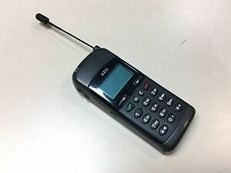

- the Instagram filter work
- the Instagram filter doesn’t work
- doesn’t work the Instagram filter
- the Instagram filter don’t work

- I feel mean when ___________________ the text messages my family sends me.

- I respond
- She responds
- I don’t respond
- I doesn’t respond

Recuerda enviar esta guía, hecha a tu profesor por correo electrónico, puede ser una fotografía. En caso de no poder hacerlo, avísale por el mismo medio. En caso de cualquier consulta, puede enviarme un correo.
Correo electrónico: alan.becar@ceclacisterna.cl
FECHA DE ENTREGA HASTA: Jueves 9 de Abril
(Favor enviar correo con título “Séptimo Básico – Apellido Nombre del estudiante”)

